From: https://www.davidstockmanscontracorner.com/phony-war-socialism/?mc_cid=ba32c7180f&mc_eid=23bf5d4e64
Date: Monday 20200406

Phony War Socialism
Where does the Donald get these assorted government lifers, apparatchiks and clowns?
According to his Surgeon General,
“This is going to be the hardest and saddest week of most Americans’ lives, quite frankly,” U.S. Surgeon General Jerome Adams said on Fox News Sunday. “This is going to be our Pearl Harbor moment, our 9/11 moment, only it’s not going to be localized. It’s going to be happening all over the country. “
And his State Department health expert, Deborah Brix, went so far as to tell people to avoid leaving their homes, even for basic necessities:
“This is the moment to not be going to the grocery store, not going to the pharmacy, but doing everything you can to keep your family and your friends safe,” Deborah Birx, head of the White House coronavirus task force, said during a White House news briefing over the weekend.
And then, of course, there is the ubiquitous Dr. Fauci, lifetime head of the National Institute of Allergy and Infectious Diseases (NIAID) with
- his 100,000-240,000 deaths projection and
- semi-full time gig as a CNN commentator on all thing coronavirus —that is to say, all things which CNN deems suitable for its audience to hear and stay ratings-glued to their TV set out of fear.
Never mind that two of these cats are about as pedigreed Swamp Creatures as you can find anywhere in the Imperial City, and the other (Jerome Adams) just finished his medical internship and residency as recently as 2006, and thereafter spent a few years professoring at Indiana University followed by a stint as chief Medical officer (whatever that is) of the Hoosier State before becoming U.S. Surgeon General ( a truly superfluous job if there ever was one).
And we do mean Swamp Creatures. Dr. Fauci graduated from Cornell medical school in 1966, took a research job at the NIAID 52 years ago, became its director in 1984 and has been in said job ever since. Can you say tunnel vision?
Dr. Brix got out of medical school in 1980, joined the US Army as a doctor, rose through the ranks at Walter Reed medical center, including several fellowships at Dr. Fauci’s labs and then was off to the CDC in 2005 and the State Department as Obama’s global ambassador on the fight against AIDS in 2014.
Is it not surprising, therefore, that these cats have been advising the Donald to approach the Covid-19 matter with public health blinders on and with the zeal that comes from a lifetime of doing the state’s purported good works from within a narrow bureaucratic silo. So their approach has been public health uber alles, meaning shut down the US economy first and ask question later about the consequences.
Then again, none of the three ever met a payroll or was elected to public office. Consequently, they have no clue that most of America’s businesses and households are leveraged up to their eyeballs, thereby having little ability to weather even a brief cash flow interruption; or that their bought and paid for elected pols are standing ready to literally open-up Uncle Sam’s fiscal veins so that he can bleed largesse into a coast-to-coast soup line that will be visited by virtually every household and business in America.
Self-evidently, the $2.2 [trillion] Everything Bailout, the Fed’s insane money-pumping and Nancy Pelosi’s impending Covid spend-a-thon #4 amount to the most massive, instantaneous eruption of socialism in US history. Confronted with the real emergency of the Great Depression and what were already three-year old bread lines, FDR would have been green with envy had he accomplished during the infamous 100 Days even 10% of what the Donald and the hysterical pols on Capitol Hill slammed thru by voice vote last week.
And for crying out loud, this is mindless socialism of the worst sort. More than 90% of the US population are going to get their $1,200 check, but there are now 159 million employed Americans and in even the worst case scenario the number of temporarily unemployed is not projected to exceed 30 million. So why are the other 129 million getting checks?
Well, it’s not to replace temporarily lost income of those who haven’t lost any. Instead, it’s to ensure that the collectivity of American consumers keep spending 100% of the aggregate amount—-$14.9 trillion at an annual rate—-which they were spending in January 2020.
That actually puts old Karl Marx himself to shame. He famously averred that “from each according to his ability, to each according to his needs”, but Washington’s new helicopter money amounts to Free Stuff to whoever was standing around the basket, whether they need it or not.
That’s even more apt with regard to the truly insane $350 billion small business lending program that offers what amounts to grants for 2.5 months worth of payrolls, utilities, loan payments and property taxes—so long as no one gets laid off.
The thing is, the business doesn’t even need to be shutdown to qualify. And it doesn’t matter how reckless its owners had been in piling on debt or operating with high fixed costs and nonexistent liquidity reserves prior to the Covid. They get the same amount of Free Stuff as prudent businesses—even direct competitors—-that incurred the costs of maintaining operating flexibility and financial reserves, and therefore could have weathered the disruption without sticking their hand in Uncle Sam’s empty pockets.
Indeed, when we suggest that the stench of corruption coming from this program–and the $500 billion/$4 trillion US Treasury/Fed plan for Big Business, which we shall eviscerate on another occasion—-will be of biblical dimension, we are not resorting to labored hyperbole. For instance, in the wee hours of Senate backroom dickering, the alert lobbyists for the LBO larcenists (nee private equity funds) managed to mangle a definition of “affiliates” such that every portfolio company with 500 or fewer employees qualifies as a “small business” and will therefore by eligible for the Free Stuff described above.
That’s right. By definition these companies have been strip-mined to pay-off previous shareholders and fund prodigious fees, expenses and leveraged dividends to current LBO managers, yet Uncle Sam is now paying their monumental interest tabs; and as far as we can tell, the quarterly management fees to the their billionaire owners, as well.
In the same vein, the Fed’s egregious bubble inflations have fostered the most unhinged venture capital bonanza in recorded history, where VCs have literally thrown tens of billions at the wall hoping to sire the next unicorn and 100:1 type returns.
Needless to say, the overwhelming share of these “burn babies” never had a chance of earning a profit, or even generating any material sales, and were heading for liquidation upon the next financial market meltdown in the cycle [style?] of 2000-2002 and 2008-2009. But most will now be on Washington’s Covid-respirator, burning the taxpayers ‘dollars in lockstep with those of the VCs.
The only difference, of course, is that the taxpayers will get nothing but permanent debt service for their generosity, even as the VCs get the upside of the single-digit percentage of VC “small businesses” that actually survive.
The fact is, there is zero basis for bailing out any business impacted by the Covid-19. It does not involve an existential threat to the nation’s well being, and the sensible public health measures which could be taken to arrest its spread—social distancing, masks and gloves—do not constitute a War for Survival in any way, shape or form.
What we actually have—if you look carefully at the state and regional data—is essentially the equivalent of a few natural disasters like hurricanes, tornadoes and earthquakes happening at the same time. In that context, you may want to provide aid to needy persons and families, but you don’t bailout millions of businesses that happen to be in harms’ way and have been living imprudently without operational and financial reserves and shock absorbers.
And besides, we already have built-in stabilizers in the form of unemployment insurance and the safety net that will automatically be replacing incomes where workers have been left high and dry and living hand to mouth.
At least the usually insufferable Mark Cuban cut to the chase on the “We are all socialists now” theme when he told Fox News that the Donald had done it just right, but should not have bothered with two pages of “loan” application paperwork. Just give everyone a bank overdraft to keep going at 100%, whether producing anything of value or not:
I would have set up overdraft protections for every single business,” Cuban told host Jesse Watters. “The way we’re doing it now, and trying to have everybody apply for a loan, that just adds friction to the process.”
….. So effectively, if you have a small- or medium-sized business, we would just cover all your checks and then the Fed would reimburse your local bank for anything that you bounce.”
“That way, you could keep all your employees employed, pay all your bills, pay your mortgage, pay your rent and utilities, and things can continue, somewhat at least, as normal,” Cuban said.
Just like that!
Nor is Cuban an aberration in his gushing enthusiasm for socialism. It seems that the entire establishment has gotten so inebriated with its self-conferred role as paternalistic guardian of America’s economic life and social well-being, that it is prepared to go full-bore Big Brother in this so-called battle against Covid-19 and who knows what comes next.
James Bullard, President of the St Louis Fed, is truly one of the most dangerous statist windbags in America, but what he recommended on a CBS news show Sunday is where much of the Washington/Wall Street and MSM establishment is heading.
How about a daily government mandated Covid-test and a badge to prove you are “safe” to leave your your house arrest?
“You know, I have good news for you, MARGARET, because we have a- there is a solution using available technology today to fix the economic part of this problem. The solution is universal testing. What you want is every single person to get tested every day. And then they would wear a badge like they would at a- after they voted or something like that to show that they’ve been tested. This would immediately sort out who’s been infected and who hasn’t been infected. That would help the health care sector. But it would also help the economy because we could interact with each other with a lot of confidence.”
Here’s the thing. This isn’t the Black Plague or a War for Survival. It’s a bad seasonal flu that is unusually contagious, but is already peaking and will be fading rapidly in the weeks ahead. As one cogent analyst noted, it will probably prove to be not much different than its SARS cousin and fall prey to the thankful arrival of warmer weather:
SARS was a coronavirus and simply died out between April and July, 2003. The media and public health officials desperately want you to think this coronavirus is different, but the evidence so far is that it follows the usual pattern with scientific publications such as “High Temperature and High Humidity Reduce the Transmission of COVID-19.”
As to the peaking thing, we will let the numbers do the talking for the 14 days since Monday, March 23 when only 42,000 cases had been reported compared to Sunday’s 332,000 and 471 deaths compared to Sunday’s tally of 9,498. During the same period, of course, the number of Americans tested soared from 279,000 to 1.762 million.
This has made for what the context-free cable TV headlines claim to be shocking numbers, but the truth is rather more nearly the opposite. What’s happening is the infected cases which were out in the community already, and which are being discovered, reported and headlined, have already begun to plateau in terms of the day over day growth rates.
To wit, the daily growth rates between March 23 and April 5 were:
- 32.2%,
- 23.2%,
- 23.1%,
- 26.2%,
- 23.1%,
- 18.9%,
- 17.6%,
- 15.4%,
- 14.1%,
- 13.4%,
- 13.7%,
- 12.4%,
- 8.7%.
By the same token, as regrettable as the Covid deaths are and tragic for the families impacted, the scare mongering by the media and reinforced by the Donald’s Covid-team is beyond the pale. It has effectively created an environment in which what they called “War Socialism” in the first half of the 20th century could thrive like never before.
During these same 14 days, 115,000 Americans have died in the ordinary course. This includes 24,800 deaths from heart disease, 22,900 from cancer, 6,500 from auto and other unintentional accidents, 6,150 from lower respiratory illnesses, 5,600 from strokes, 4,600 from Alzheimer’s, 3,200 from diabetes and 1,800 from suicides.
So, yes, an additional 9,000 people died with Covid-19 during that period—-a major percentage of whom had co-morbidity conditions including some or all of the above illnesses. That much is clear from the Italian situation, that has been the poster boy for the Black Plague hysteria. But as even its own government has now conceded,
…….almost all those elderly dead had “comorbid” conditions of cardiovascular disease, diabetes, or hypertension. Similarly, almost everyone who has died in Italy has been over age 70, and virtually all had comorbid conditions: In fact, half of those who died had three or more. Almost nobody under 50 has succumbed and almost all who have also had serious existing medical conditions. This is a condemnation of the nation’s health care system; not a portent of America’s future.
Italy:
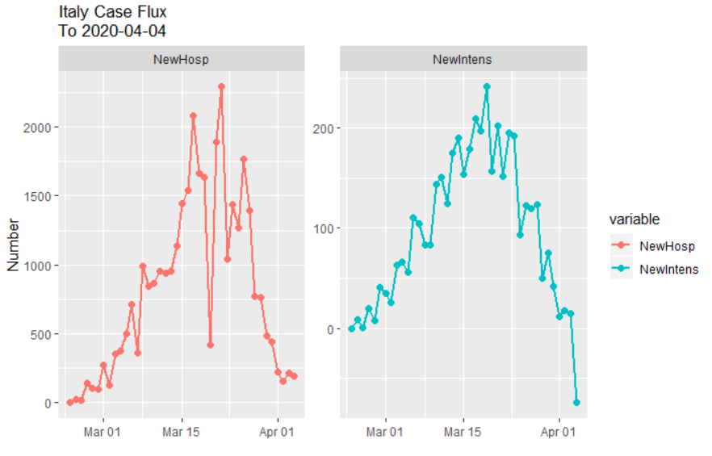
In short, the Covid-19 is a seasonal public health management challenge. But its been turned into an opening for the statists and politicians to launch a Phony War Socialism from which it will be virtually impossible for capitalist prosperity and constitutional liberty to ever recover.

